Launch the Summary Report Tool by open SummaryReportTool.exe or from MOVES main GUI (future)

The application will connect MariaDB on local computer using the MOVES default credential, username: moves and password: moves

If the default credential failed to connect, there will be a prompt pop out to let user edit and save/submit the customized credential. Next, the application will retry MariaDB connect with the user updated username and password.

After successful connect to MariaDB, the main panel will show.

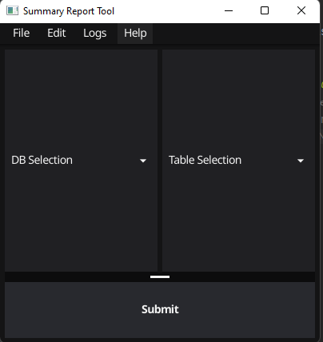

Figure .0 Main Panel

To explore MOVES output database

1. Click the DB Selection dropdown box and select desired MOVES output database
2. Click the Table Selection dropdown box and select desired table
   1. The application only support viewing the following 8 tables
      1. "movesactivityoutput",
      2. "movesoutput",
      3. "rateperdistance",
      4. "rateperhour",
      5. "rateperprofile",
      6. "rateperstart",
      7. "ratepervehicle",
      8. "startspervehicle"
3. Click Submit button

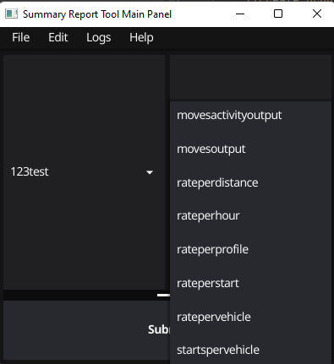

Figure 1.1 Table Selection

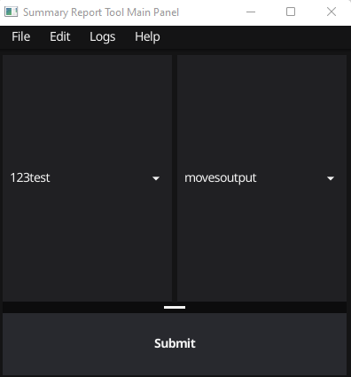

Figure 1.2 Main Panel with dropdown boxes selected

The Data View Table will display after scanning data from MariaDB, the speed is depending on the size of the output table that user selected.

By default, all ID related columns are displaying numeric ID number. Please refer to MOVES cheat sheet: [OnRoad Cheat Sheet](https://github.com/USEPA/EPA_MOVES_Model/blob/master/docs/MOVES3CheatsheetOnroad.pdf) , [NonRoad Cheat Sheet](https://github.com/USEPA/EPA_MOVES_Model/blob/master/docs/MOVES3CheatsheetNonroad.pdf)

Decoded ID will be displayed after clicking update button 

There are 3 panels in the Data Viewing Window.

1. Top: Tool bar panel, with query and unit messages
2. Left: Filter panel
3. Right: Data table
   1. Data table has both vertical and horizontal scroll bars

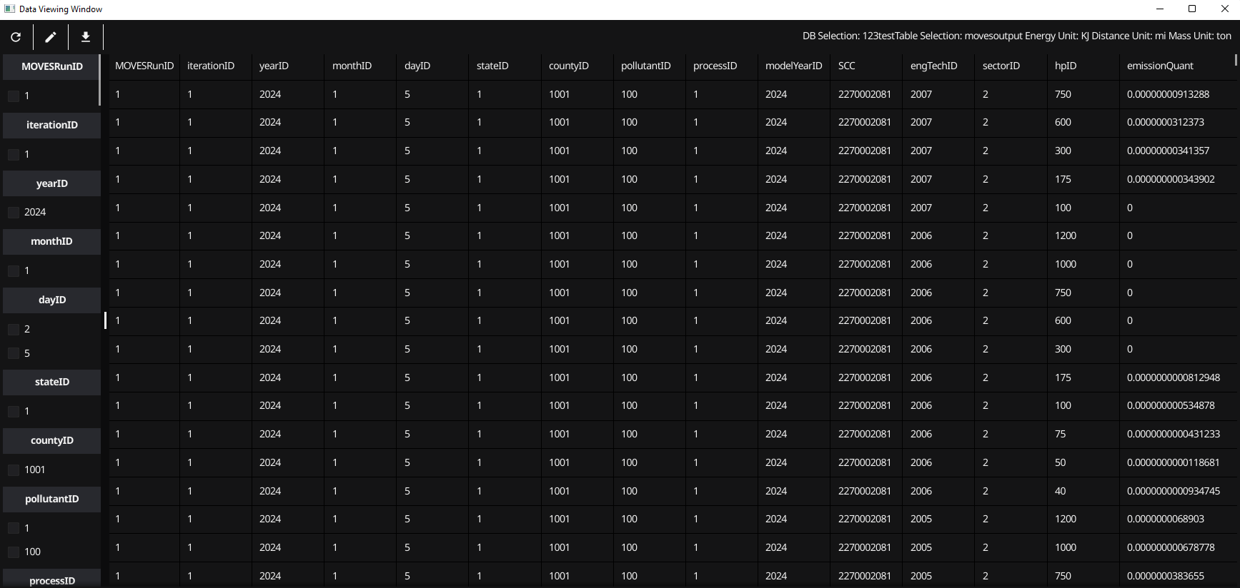

Figure 2 Data Viewing Window with numeric ID columns

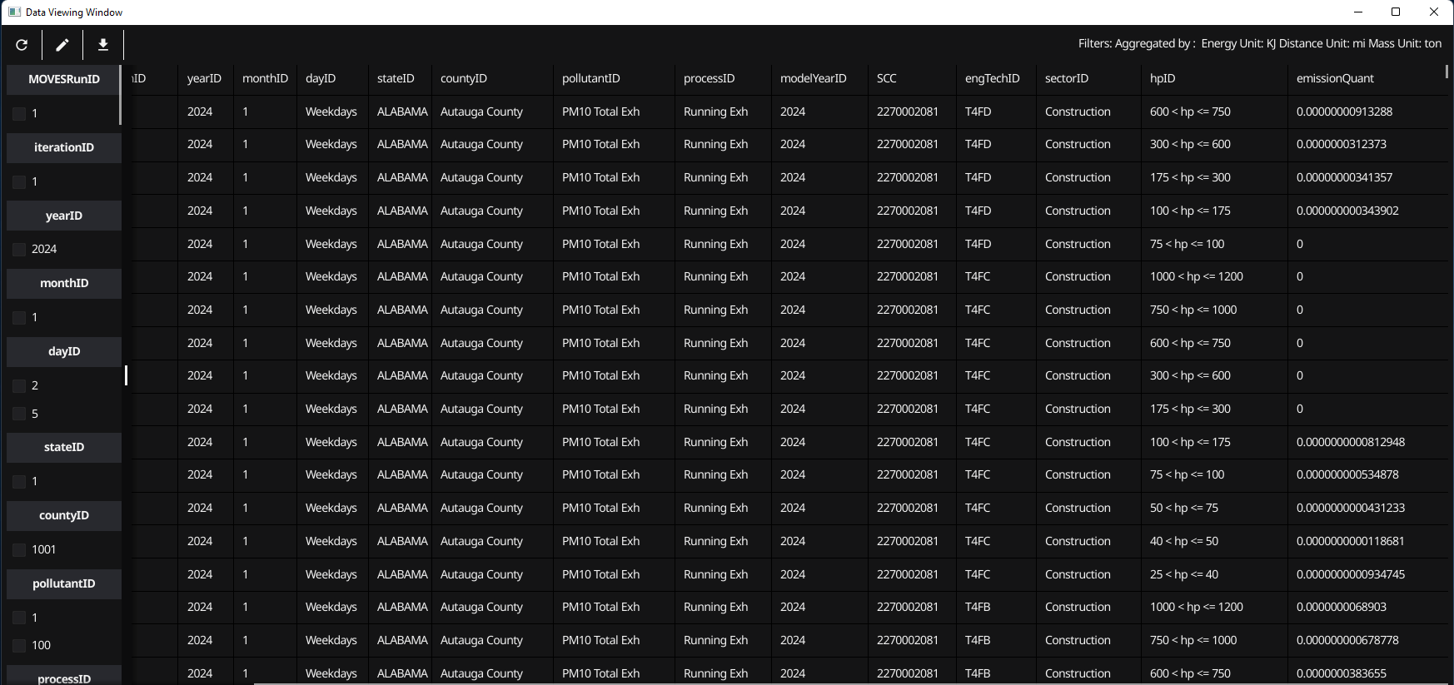

Figure .1 Data Viewing Window with decoded ID columns

**Toolbar**



Figure 2.2 Toolbar

Tool bar has 3 buttons:



Figure 2.3 Update button

Update: Update the data table base on filter and aggregation checkboxes status.



Figure 2. Plot button

Plot: Open Plot Configuration Window (only works for activity and movesoutput tables), cover it in next chapter



Figure 2. Download button

Download CSV: download data from data table to a .csv file



Figure 2. Message Label in the Toolbar

Message: the message label on the right corner will display the unit selection from its MOVES run. MOVES unit can be change in the MOVES GUI before MOVES execution. The message will also display what columns are the filters and/or which columns are aggregated/grouped.

**Filter Panel**

1. Filter panel has two sections.
   1. Filter section
      1. Group of checkboxes with numeric ID such as roadTypeID : 1, 2, 3, 4, 5
   2. Aggregation section
      1. Group of checkboxes with column names, for example: yearID, processID, and pollutantID
2. Filter panel has vertical scroll bar
3. Filter panel will only display non-empty columns as checkboxes
   1. For example, if there is no filter checkbox for model year, it is because the model year column values are null. A null value column will not be displayed in both data table and filter panel.
4. Check all options in a checkbox group is equal to check nothing.
   1. For the following example, result A is equal to result B
      1. A checked dayID 2(weekend), and 5(weekday)
      2. B checked nothing in the dayID group

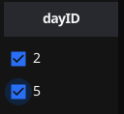

Figure 2.7 check all box

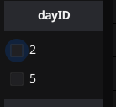

Figure 2.8 check no box

Filter example:



Figure 2.9 Filter message

Figure 2.6 is the result by checking dayID 2(weekend) checkbox. The filter will ignore the result of dayID 5 (weekday) and only display data rows for dayID 2(weekend)

Aggregation example:



Figure 2.10 Message with aggregation

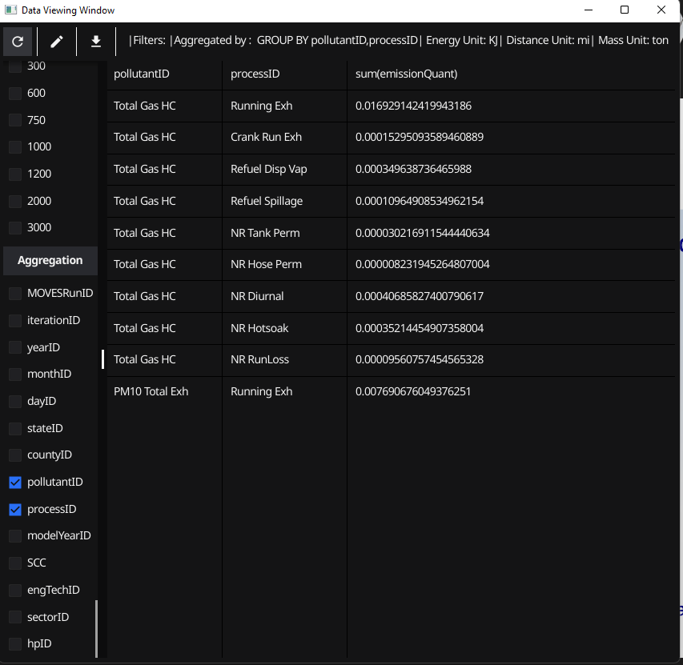

Figure 2.11 Aggregation example

The above screenshot is a demonstration for aggregation. With pollutantID and processID checked. The data table will sum all emissionQuant that associated with same pollutantID and processID combination.

Aggregation also can work together with the filters.

**Data Table Panel**

Data table Panel only contains not null columns.

**Plotting Window**

Activity and movesoutput table support stackbar plot.

To start with plotting, the data table need to reduce its demention.

For example, to show the relationship between pollutant, process over emission quantity.

1. Check both pollutantID and processID in the aggregation panel
2. Click update button
3. 3 click plot button

If 1 or 2 columns are included, the plot configuration window will show

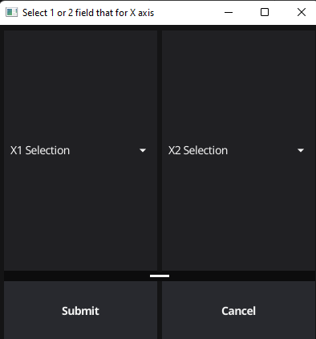

Figure 3.0 Plot Config Window

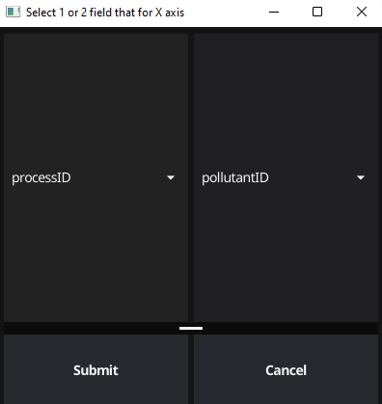

Figure 3.1 Plot Config with processID and pollutantID

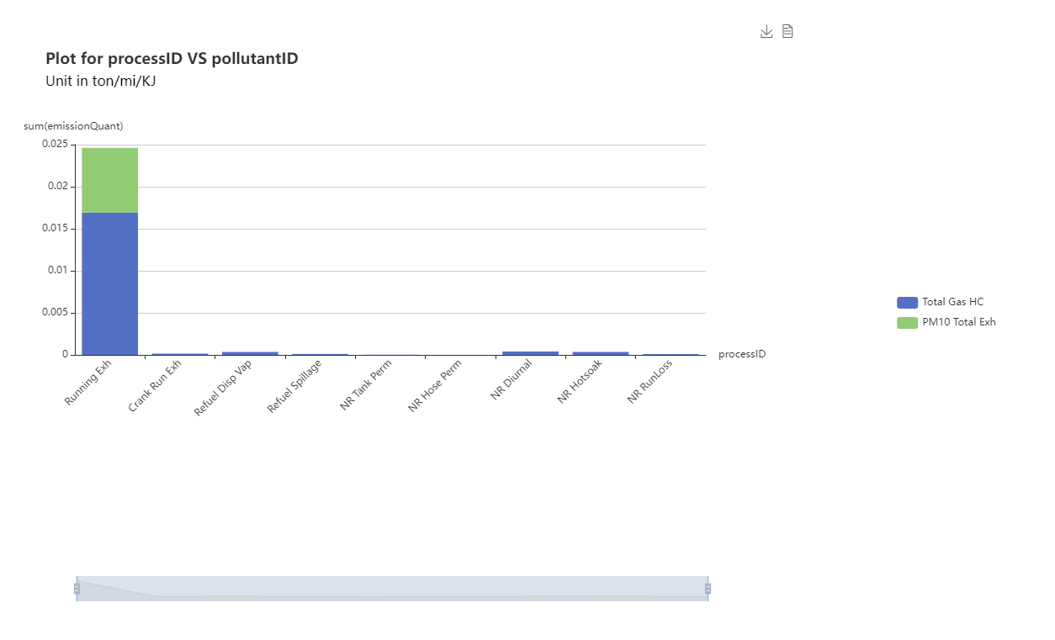

Figure 3.2 Plot demo

Select X1 and X2 and click submit button. The application will generate a .html file and open it by the default browser.

For example:

Figure 3.1 will generate a plot in same shape with figure 3.2

X1 is process in this demo, there are horizontal aligned

X2 is pollutant, the stacked bar in blue and green

The drag bar in the bottom of figure 3.2 can be resize and move to left and right. This allows user to zoom in and out the plot.

The legend on the right is clickable. Enable and disable the stacked bar.

The Download PNG button can be found on upper right side, it open a folder navigator and let user select the save path.

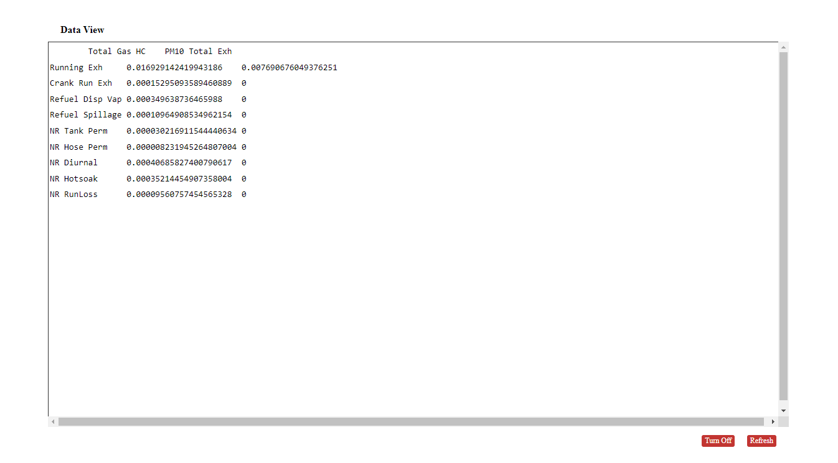

Figure 3.3 Data View button

The Data View button located on the upper right corner. Data View panel will display after button click. This data table is supporting the plot, it is transformed (long to wide) from the data table in the Data Viewing Window.